Software Requirement Document
Project Name: Xin1 Integrated Powertrain Domain Controller
Technology Owner:
Version: V001
Document No: Xin1_SRS_001

Change History
Version | Date | Author | Reviewer | Approver | Change description
001 | 28/07/2026 | Ratneswar Sahoo | Pankaj D | Rajiv Kumar | Initial Draft

TABLE OF CONTENTS
1 Introduction 4
1.1 Document Scope 4
1.2 Requirements Definition 4
1.3 Terminologies 4
2 Project Requirements 5
2.1 Purpose 5
2.2 Feature List 5
3 System Description 7
3.1 Introduction 7
3.2 Vehicle System Overview 7
3.3 Block Diagram 8
3.4 ECU Interface 8
4 Embedded Software Requirements: 8
4.1 Design Requirements 9
4.2 Diagnostics Requirements 9
4.3 Functional Safety (FuSa) and Cyber Security Requirements 9
4.4 Validation Requirements 9
5 User Interface Requirement 10
6 Considerations/Constraints (SW) 10
7 Other Requirements 10
7.1 Resource Consumption Requirements 10
7.2 Performance Requirements 10
7.3 Operating System Requirements 10
7.4 Project Timeline 11
7.5 Calibration & Code Flashing Sequence 11
7.6 Patches and Updates 11
8 Software Requirements Signoff Details 11
9 Appendix 11

Introduction

Document Scope
The purpose of this document is to define the software requirements for the Xin1 Integrated Powertrain Unit Application Software.
The software shall:
- Manage vehicle operational states.
- Coordinate propulsion control.
- Coordinate steering auxiliary inverter operation.
- Coordinate brake compressor inverter operation.
- Supervise DCDC converters.
- Manage charging communication.
- Perform diagnostics.
- Implement functional safety mechanisms.
- Implement cybersecurity functions.

Requirements Definition
The interpretation of different requirements is controlled by the following definitions:
- Shall, Must - A binding requirement (verifiable) of the component within the scope of this specification.
- Should – A non-binding requirement (recommendation) of the component within the scope of this specification.
- Will - A requirement that is implemented outside of the scope of this specification, that is required for the successful implementation of this specification.
- May – This word in the text expresses a permissible practice or action. It does not express a requirement of the specification

Terminologies
Acronym | Definition
EVCU | Electric Vehicle Control Unit
BMS | Battery Management System
HPC | High Performance Controller
CCS2 | Combined Charging System Type-2
HVIL | High Voltage Interlock Loop
DCDC | DC/DC Converter
OBD | On Board Diagnostics
OTA | Over-The-Air Update
UDS | Unified Diagnostic Services
CAN | Controller Area Network
PLC | Power Line Communication
Table 1: Terminologies

Project Requirements

Purpose
The Xin1 Integrated Powertrain Unit shall integrate propulsion control, auxiliary motor drive control, low-voltage power generation and vehicle control functions within a single enclosure.
The Xin1 system shall:
- Convert HV battery energy into traction power.
- Supply regulated LV power to vehicle loads.
- Control steering pump motor operation.
- Control brake compressor motor operation.
- Coordinate propulsion and regenerative braking.
- Support EV charging communication.
- Ensure functional safety and diagnostic functionality.
- Support commercial vehicle applications including HCV, ILM and Bus variants.

Feature List

Stakeholders Description
The following table contains details of all project stakeholders:
Sr.no | Function | Name | Designation
1 | System Engineering |  | System Architect
2 | Functional Safety |  | FuSa Manager
3 | Power Electronics |  | Technical Lead
4 | Software Development |  | SW Architect
5 | Hardware Development |  | HW Architect
6 | Validation |  | Test Manager
7 | Program Management |  | Project Manager
8 | Integration
Stakeholder details

List of features / Broad vehicle level requirements
The given table below contains the list of required features / vehicle level requirements / Applicable PAT requirements.
Veh_REQ_ID | Vehicle Level Requirement / PAT requirement | Remarks
Veh_REQ_01
List of Relevant PAT feature List

Reference documents

System Requirement Document

System Architecture Design Document

Reference of standards/regulations
Document Number | Definition
ISO 26262 | Functional Safety
ISO 21434 | Cybersecurity
ASPICE v4.0 | Software Development Process
AUTOSAR | Software Architecture
ISO 15118 | Charging Communication
IEC 61851 | Charging Interface
UNECE R155 | Cybersecurity
UNECE R156 | Software Update
List of standards

System Description

Introduction
The Software controls and supervises all Xin1 aggregates.
Major software functions include:
- Vehicle State Manager
- Torque Coordinator
- Energy Management
- DCDC Supervisor
- Steering Inverter Control Manager
- Brake Inverter Control Manager
- Charging Manager
- Diagnostics Manager
- Safety Manager
- Cybersecurity Manager

Vehicle System Overview
The software executes on:
- Main CPU
- Sub CPU
The software communicates with:
- Traction Inverter-1
- Traction Inverter-2
- Steering Inverter
- Brake Inverter
- DCDC-1
- DCDC-2
- DCDC-3
- HVIL
- PLC Interface
- Vehicle CAN Network

Block Diagram

ECU Interface

External Interface
Interface ID | Description
SW_ExtIF_01 | CAN Interface
SW_ExtIF_02 | Battery pack HV supply through PDU
SW_ExtIF_03 | PLC Interface
SW_ExtIF_04 | HVIL Interface
SW_ExtIF_05 | Analog Input Interface
SW_ExtIF_06 | Digital Input Interface
SW_ExtIF_07 | HSD/ LSD Interface
SW_ExtIF_08 | Coolant IN/OUT
SW_ExtIF_09 | 24V Output
SW_ExtIF_10 | 12V Output

Internal Interface
Source | Destination | Interface
Main CPU | Sub CPU | CAN
Main CPU | Traction Inverters | Internal Communication
Sub CPU | Steering Inverter | Internal Communication
Sub CPU | Brake Inverter | Internal Communication
Sub CPU | DCDC Modules | Internal Communication

Embedded Software Requirements:

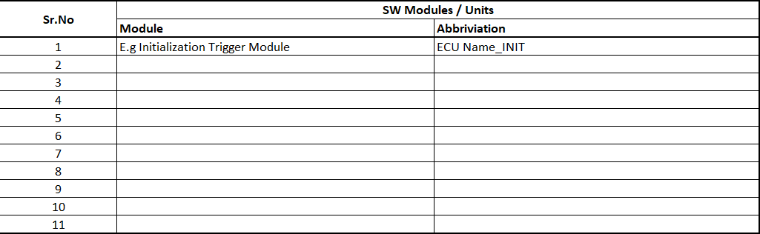

Design Requirements
Sys_Req_ID | Sys_Arch Ele_ID | SW  Module | Sw_Req_ID | Req_Desc | Type (Fn/Non-Fn) | Group (Design/Ext/User Int) | Priority | Ctg
 |  |  |  | The software shall transition from OFF state to WAKEUP state within T1 ms after detection of a valid wake-up request. | Fn
The software shall transition from WAKEUP state to READY state only when all of the following conditions are TRUE:
- HVIL_Closed
- BMS_HV_Ready
- No Critical DTC Active
 |  |  |  | The software shall transmit the current Vehicle_State on CAN FD every 100 ms ±10 ms.
 |  |  |  | The software shall declare Main_CPU_Communication_Lost if no valid supervision message is received from the Main CPU for more than 100 ms.
 |  |  |  | The software shall declare Sub_CPU_Communication_Lost if no valid supervision message is received from the Sub CPU for more than 100 ms.
 |  |  |  | The software shall distribute requested propulsion torque equally between Traction_Inverter_1 and Traction_Inverter_2 when both inverters are available.
 |  |  |  | The software shall redistribute propulsion torque to the remaining available traction inverter within T1 ms following loss of one traction inverter.
 |  |  |  | The software shall command zero propulsion torque within T1 ms after receipt of a valid Safe Torque Off request.
 |  |  |  | The software shall sample the HVIL input with a period not greater than T1 ms during READY, DRIVE and CHARGING states.
 |  |  |  | The software shall detect an HVIL open condition within T1 ms after a change of HVIL status.
 |  |  |  | The software shall issue an HV shutdown request within T1 ms following detection of a safety-critical HV fault.
 |  |  |  | The software shall set Steering_Available = FALSE when no valid steering status message is received for more than T1 ms.

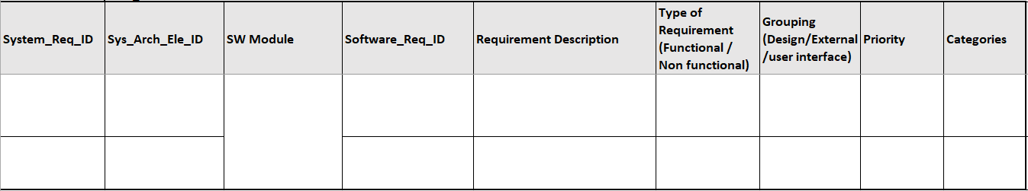
Software_Req_Document

Diagnostics Requirements
Sys_Req_ID | Sys_Arch_Ele_ID | Req Name | Sw_Req_ID | Flt_Req_Desc | Type(Fn/Non-Fn) | Grp(Design/Ext/User Int) | Priority | Ctg

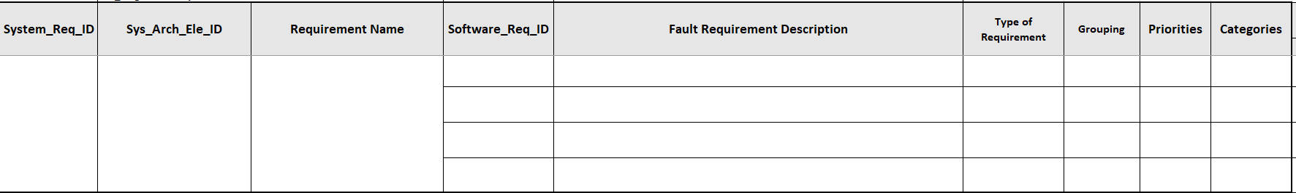
SW_Diagnostics_Req_Doc

Functional Safety (FuSa) and Cyber Security Requirements

Validation Requirements

MIL Validation
SIL Validation
HIL Validation
Lab car Validation
Vehicle Level Validation

User Interface Requirement

Considerations/Constraints (SW)

Other Requirements

Resource Consumption Requirements
Memory | Consumption objective
Flash Utilization | ≤ 80% of available memory
RAM Utilization | ≤ 80% of available memory
CPU Utilization | ≤ 70% average utilization
NVM Utilization | ≤ 80% allocation

Performance Requirements
- Efficiency –
- Compliance –
- Coverage –

Operating System Requirements

Tasks
Sr. No. | Tasks | Time (ms) | Description
1
2

Interrupts
Sr.No. | Interrupt Description | Priority

Project Timeline

Calibration & Code Flashing Sequence

STEP | DESCRIPTION
Calibration and code flashing sequence

Patches and Updates

Software Requirements Signoff Details

Sr.no | Function | Name | Designation
1
2
3
4
Software Requirement Signoff

Appendix

